Work Instruction

Title: Electronics Design Instruction
Rev. No. | Rev. Date | Prepared By | Verified By | Reviewed By | Approved By
00 | 30 Apr 21
 |  | Sumate P.  Electronics Specialist | Ekkarat T.  Electronics Department Manager | Dr. Kirkpong K.  Chief Research Development & Engineering Officer

PURPOSE/ วัตถุประสงค์
The purpose of this instruction is to define the design process used for DACON inspection technologies.

REFERENCED DOCUMENT/ เอกสารอ้างอิง
N/A

DEFINITIONS/ คำจำกัดความ
N/A

RESPONSIBILITY/ หน้าที่รับผิดชอบ
Electronic engineer is responsible for implementation and management of this procedure.

EQUIPMENT USED/ อุปกรณ์ที่ใช้
Computer/ Laptop

PROCESS AND DETAILS / กระบวนการและรายละเอียด

DESIGN REVIEWS
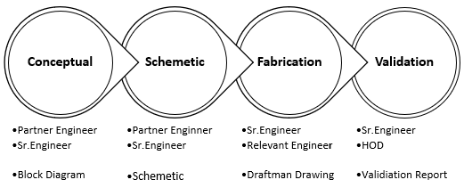
Every project which has proceed under researches and developments (RDD) shall be followed the process design reviews as below chart.

Conceptual Design:
The conceptual design shall be created during project approval request to be describing of design direction. How will project perform? How will product look like? How will system work out?
Authorized of Approval: 1. Partner Engineer 2. Senior Engineer
Documents for Approval: Block diagram or Presentation file

Schematic Design:
Electronics design diagram to be reference in PCB layout which has been proved on theory or practice experiments.
Authorized of Approval: 1. Partner Engineer 2. Senior Engineer
Documents for Approval: Schematic diagram, Simulation (optional)

Fabrication PCB:
PCB design must be completed with draftsman drawing to discuss with relevant engineer for conform board size/ shape or locking positions.
Authorized of Approval: 1. Relevant Engineer 2. Senior Engineer
Documents per Approval: Draftsman drawing and Bill of Material

Validation Results:
Final process shall be proved by validation report but can be combined all board design in single report or separately. Report can be presented in any formats (documents/ check-sheet/ presentation) but shall be followed to standard template.
Authorized of Approval: 1. Senior Engineer 2.Electronics HOD
Documents per Approval: Validation reports

ELECTRONICS ONLINE APPROVED (LINK)
All electronics design resources shall be requested to review and get approval, then designer will place authorized person name.
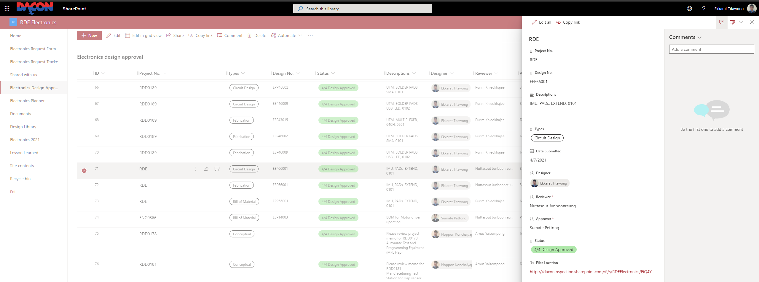
    - Project No.: Project number as design will registered (if center, place RDE
    - Design No.: Design code EEPE, EEL CODEX (leave free if general documents.
    - Descriptions: Place design name or short description for general documents.
    - Type (s): -
      - Conceptual: Proposal, block diagram, calculation page.
      - Circuit Design: Schematic design.
      - Bill of Materials: Component list (BOM. BOC, Share Cart)
      - Fabrication: PCB design or draftsman page.
      - Validation: Testing results, investigation, or experiments report.
    - Date Submitted: Date of submit documents (normally default will be today)
    - Reviewer: Add person who will be reviewer.
    - Approver: Add person who will be approver.
    - Status (s): -
      - 1/4 Awaiting Submitted design: Designer to reviewer (manual request)
      - Awaiting Reviewer Approval: Reviewer will be approved (automatic)
      - Awaiting Final Approval: Approver will be approved (automatic)
      - Final Review: -
        - 4/4 Design Approved: Reviewer and Approver confirmation.
        - 4/4 Design Rejected: Reviewer or Approver reject to design
(After rejected, designer will update as recommendation then proceed again from beginning)
    - Files Location: Place SharePoint link to folder of design approve request.
    - References: Place additional link (share cart, design note, etc.)
    - Files Associated: Attached files for approved request (can be more than 1)

ENGINEERING ELECTRONICS CODE (EEP CODEX)
Designer shall reserve code and register design name to EEP CODEX before starting to create work. Format of CODEX and name must be followed in standard and will approved by EE. Admin. Designer shall be responsible to monitor design update, file location, remark and note.
EEP | 1 | 2 | 3 | 4 | 5 | 6 | 7 | 8 | 9 | 0
Design Type (s) | Breakout Board | Sensor Adapter | Reserved | UTM | CAL | IMU | MFL | Reserved | Reserved | Multi-Board Design
    - CODE: Place EEP CODEX for design as per types
    - Description: Place design name in short word (respected to standard format)
    - Revision: Design version/ revision in 4 digits
    - Date: Lasted update or registering date.
    - Designer: Design owner or main responsible for each design.
    - Status (s): -
      - Designing: Design which still be ongoing which not completing.
      - Pause: Design which has been hold-on but shall be resumed later.
      - Fabricated: Design release to fabrication (passed process quotation)
      - Testing: Design which being to assembly components and testing.
      - Revise: Remarking update next version or note for failed in testing.
      - Release: Currently status is used in existing system.
      - Cancelled: Design which will not continuous (can be also deleted)
      - Obsoleted: Design which been replace by newer version.
    - Remark: Please comment or short note for remind design concerns.

ITEM REQUISITION
Y
N
N
Y
N
Y
Y
N
Item Request
On Board Installs
BOM and BOC
BOM
Reviews
BOC
Purchase Request [PR]
ENG Store
Approval
Wait Next Day
EE CODE
Store: Remaining Quantity
Complete
< 14:00
Return to Requestor.
Revise
Received
    - Designer has responsible to create Bill of Material (BOM, generally has automatic generated from design software) and Component Request (BOC)
    - Requisition’s components shall be separated in 2 types.
      - Components which generated from design software shall be purchased through Bill of Material (BOM) and spend cost breakdown in budget of RDD.
      - Components which used in general and did not mount on PCB shall be purchased through Component Request (BOC) and spend cost breakdown in budget of RD&E
    - Admin Dept. is responsible to review item requisition format (code, name) and available stock (obsoleted, backorder) or duplicate item (forward list to ENG store for identify)
      - Components which generated from design software shall be purchased through Bill of Material (BOM) and spend cost breakdown in budget of RDD.
      - Components which used in general and did not mount on PCB shall be purchased through Component Request (BOC) and spend cost breakdown in budget of RD&E
    - When requisition item was arrived at RD&E store and identified. It will be returned to requestor if it was purchased through BOM item. Requestor shall follow by themselves to RD&E store in case of BOC item.
    - Purchasing request quantity [n+3] (Purchase quantity can be negotiated to discount prices, decided by admin dept.)
    - Components for 1st prototype in fixed asset item to be used in reference.
      - Components for 1 set reserving, in case of accident damage during assembly.
      - Components for assembly n set (s) will be provided to production for assembly.
      - (Quantity n is number of boards required from RD&E project (including spare))

ELECTRONICS CODE

Part Code
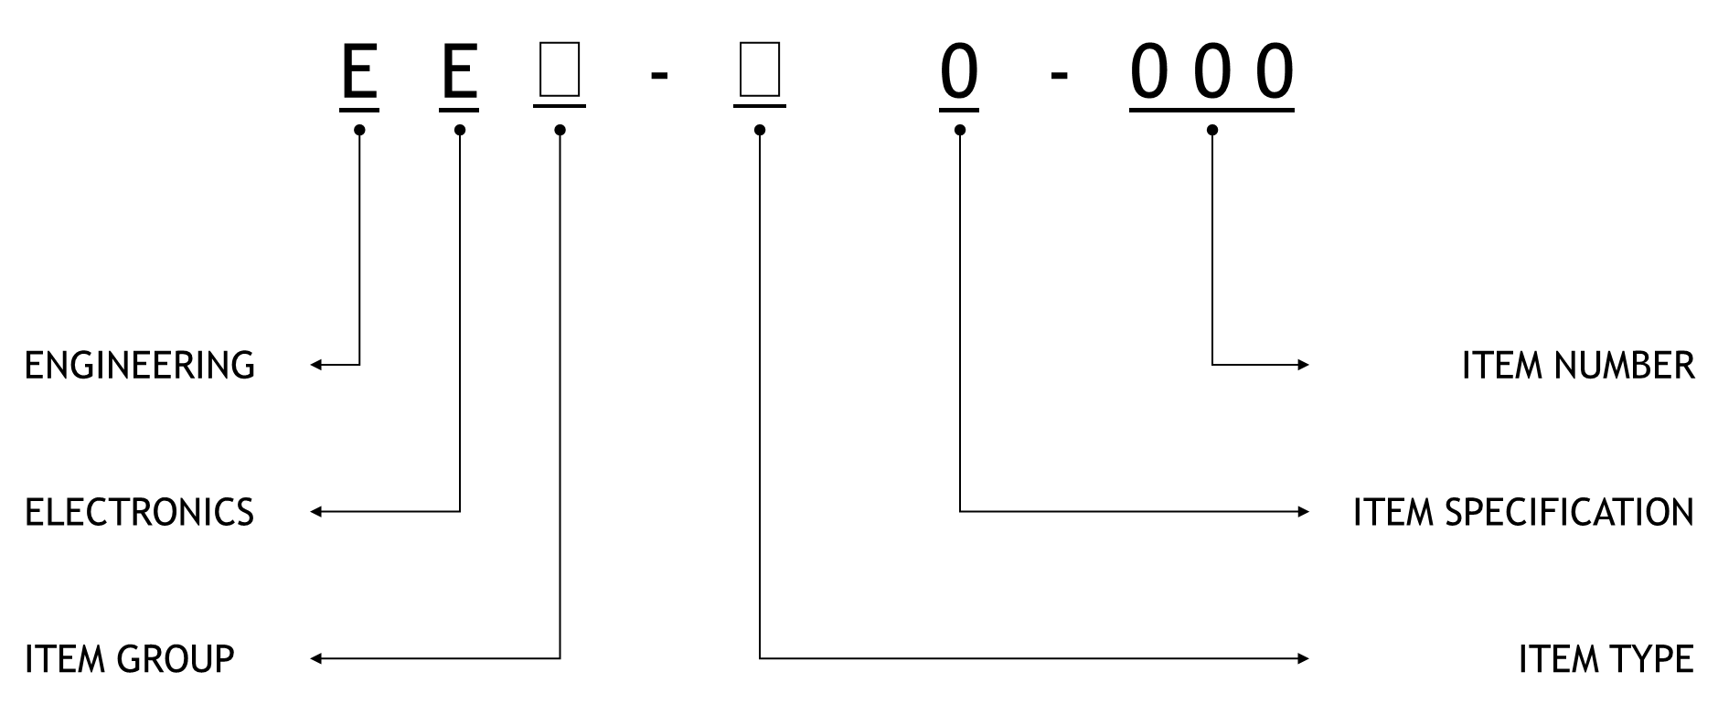
- EEA-A1-005: RES SMD 220K OHM 0.1% 1/16W 0402
- EEG-C3-001: 2-WIRE LCD VOLTMETER

Finish Good Product
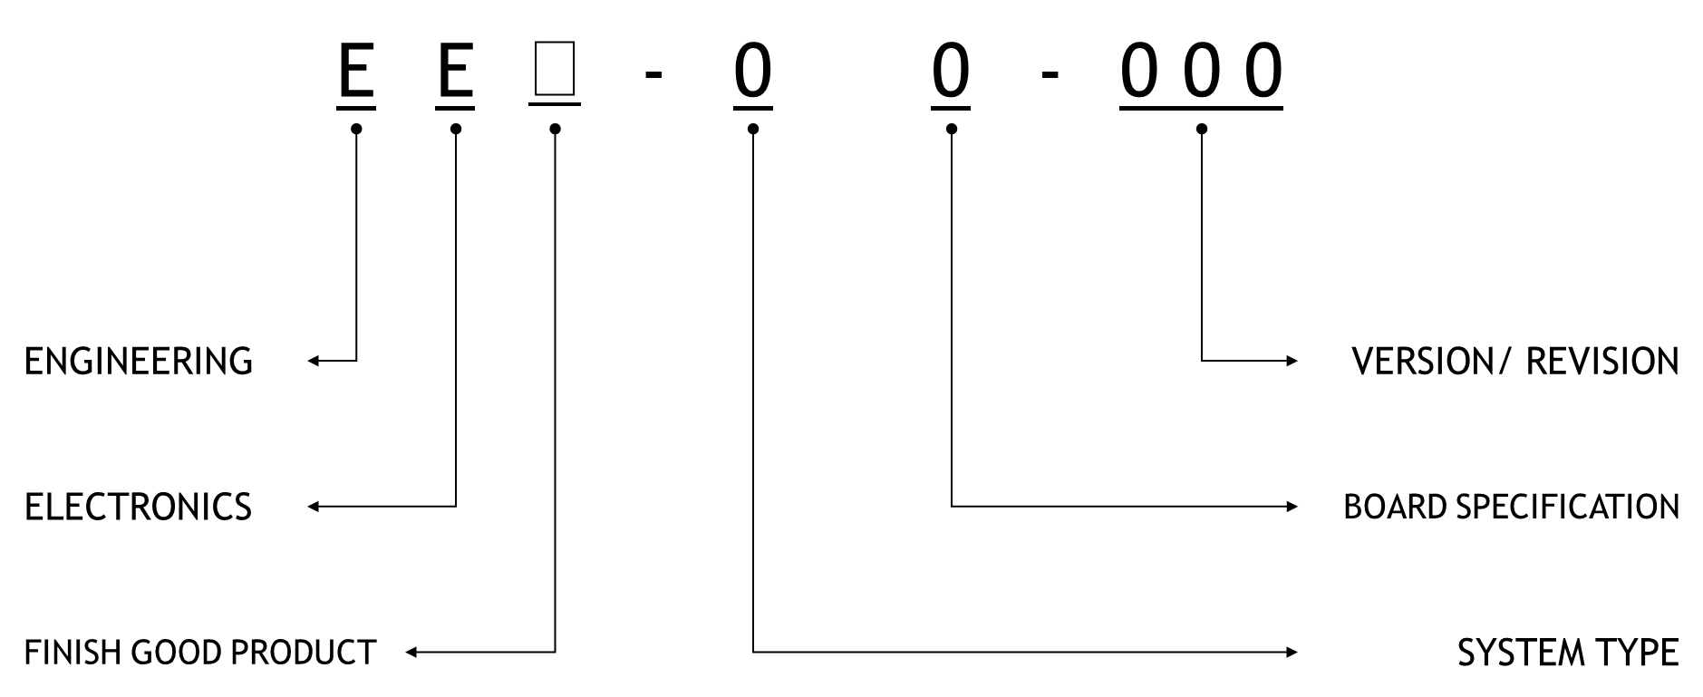
- EEP-41-003: UTM, DATA ACQUISITION, 0301
- EEP-52-006: CAL, ADC, 16CH SUPPORTED, 0205.

Wiring Diagram
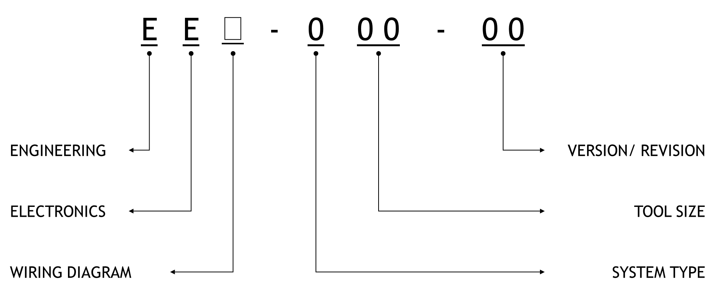
- EEL-403-22: UTMC, 03, OVERVIEW, 22
- EEL-712-05: MFL, 12, BOARD DIAGRAM, 05

Item Name Format
      - Components Description
ITEM DESCRIPTION, SPECIFICATION/ MODEL/ VERSION, …, …,
Component’s description has referenced to Digi-Key Electronics parts search and will register by all UPPERCASE characters.
- Designer should be identified item number which available in SAP system into BOM before request approval or request generate new code from EE. Admin.
- If EE. Admin found issue such as, duplicate item, request generate new SAP but duplicate to available on system, item description is incorrect to standard. Thus, requesting MUST be rejected then inform designer about their issue.
- If project was slow down due to rejected process, designer shall be responsible for complained.
      - Board Design Name
SYSTEM TYPE, FUNCTIONAL/ SPECIFICATION/, …, …, VERSION + REVISION
  - Version: Number will change when circuit was changed, and revision number must be always starting from 00
  - Revision: Number will change when layout has updates (colors, components position, etc.) but circuit keep original circuit.
Shall register design name in all UPPERCASE character and maintain short word in meaning per above format.

FILES MENEGEMENTS

- SharePoint: Useful for storage data file and all documents in online server which can be access for anywhere and types of devices. Finish good product shall be present to public to explained of design details and results validation.
- MS Teams: Helpful for update work in progress and communication in formal and private discussion. Issue requisition form have been included in this platform.
- OneNote: Products library which collected resources and master files which can be published to public within authorized.

Microsoft SharePoint

File Storage
System folder which should not be removed or moved are “Apps” and “Request Form” because will affect to the performing background. Cover page image shall be stored in folder “MS Teams Cover Page” by 1 item per project to present of conceptual.

Electronic Design and Files Associated
Almost files on the list below have been generated automatically from design software (Altium Designer) but some of them need to be created manually by designer. (EEP and EEQ should follow this template, but EEQ has not be controlled and can be skipped to be optional files.)
FILE TYPE | DESCRIPTION
*. PrjPCB | Altium PCB Project
*. SchDoc | Altium Schematic Document
*. PcbDoc | Altium PCB Document
*. PCBDwf | Assemble Drawing
*. Cam | Altium CAMtastic Document (including Gerber generated)
*. csv | Pick and Place
*. xls | Bill of Material
*. step | 3D Model
*. pdf | Schematic
*. pdf | Assemble Drawing (EEP? _FAB)
*. docx | Validation Report (storage in main circuit, share link to associated design)
*. pdf | Quotation (PCBA, including functional tests cost in optional)
*. docx | QA/ QC Testing Procedures (optional)
*. xlsx | QA/ QC Check-sheet (optional)

Project Resources
Sub-folder will be grouping by year as the priority, then will be separate again by project number and numbering shall be provided from accountant. Master BOM in release version will be provided to production for assembly product.

Documents Control
It stored relevant template files that designer must refer performing project.
- W: Work Instruction _Subject of contents
- P: Procedures _ Subject of contents
- NCR Number: Shall be provided from QSMS.

Project Presentation
        - Go to “RDE Electronics” page and choose “Add” and “News post”
        - Select template and create presentation content.
        - Published post for presenting of successfully event, can be modified content by “Edit” option on the right tap.
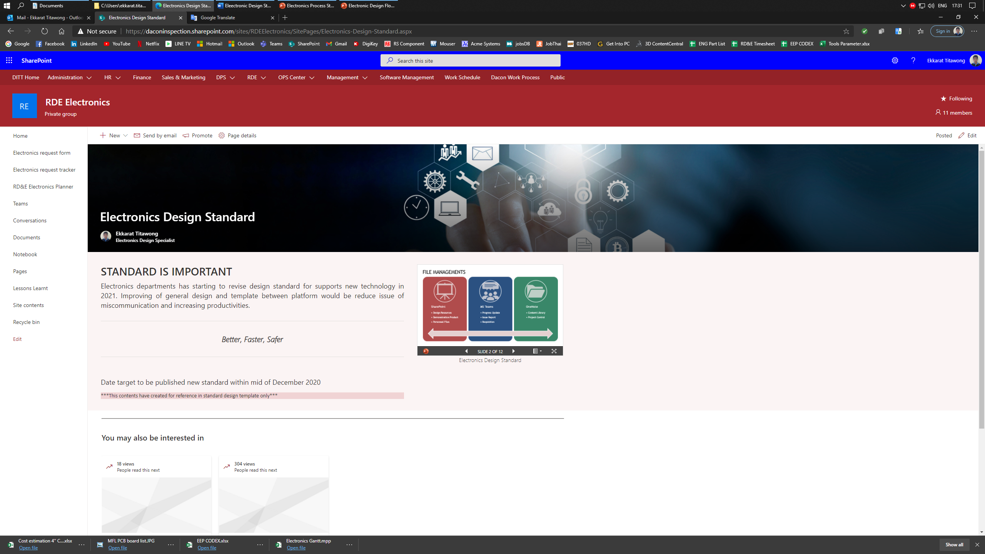

Microsoft Teams

Bucket Structures
System has allowed to complete activity for task only. Bucket will be separated by activity types and will register project/ task under relevant bucket.

Tasks Template
        - PROJECT NUMBER: PROJECT NAME
Please use 7 digits for project number and UPPERCASE style for project name.
        - Date Start – End
Starting from project approved to estimated completed but can be extend by inform via memo when close project.
        - Note
References to project description which declared in project memorandum.
        - Checklist
- YYYY DD MM Assigned, FINISH GOOD NUMBER: Conceptual and project approval (%)
Complete: Top managements has been approved your project
- YYYY DD MM Assigned, FINISH GOOD NUMBER: Circuit design (%)
Complete: Design has been reviewed by partner engineer and senior level
- YYYY DD MM Assigned, FINISH GOOD NUMBER: Components request (%)
Complete: List of order has been submitted to issue PR
- YYYY DD MM Assigned, FINISH GOOD NUMBER: Fabrication file discussion and quotation (%)
Complete: Design has been reviewed by senior level and relevant then got confirmation about receiving PO from supplier
- YYYY DD MM Assigned, FINISH GOOD NUMBER: Prototype board assemble, manual (%)
Complete: Testing result has been approved from senior level or HOD. Production supervisor confirm received delivery item.
- YYYY DD MM Assigned, FINISH GOOD NUMBER: Registered design and Close project (%)
Complete: HOD confirm to close project
        - Comments
Update status, Issue, and changes by Engineer and comments, decision by Senior Level, Relevant, and HOD

Tasks Update
        - Tasks will be created and assigned from supervisor level and submitted to HOD for approval.
        - Tasks shall be matched schedule with project planning on master file which communicated with other departments.
        - Responsible members shall update progress (checklist, percent completed) at least one per week.
        - Supervisor level shall summarize project progressive and submit to HOD to be planning new direction for each task in new week.
        - If members have missing to update, this will be affected to KPI score in yearly evaluation.

Attachments
        - Upload file to SharePoint to correctly location which system allowed.
RDE Electronics - MS Teams Cover Page - All Documents (sharepoint.com)
        - Select option “Add attachment” and choose “SharePoint”.
        - Choose you file which uploaded and press “Save”.
        - Click “Shown on card” for present design conceptual.
(Share on card shall present only cover page, should 0. show Checklist.)

Microsoft OneNote
OneNote platform has represented for content library which contained of storage documents files destination. Electronics Design Library has combined in RDE Electronics site on left side screen.

New Content
        - Electronics Design Library in OneNote has specified solution to add content with Link only.
        - Upload design/documents files to SharePoint folder as recommended location.
        - Fill display name for link file. (generally, display name will be same as file name)
        - Insert link of uploaded file, then press OK.
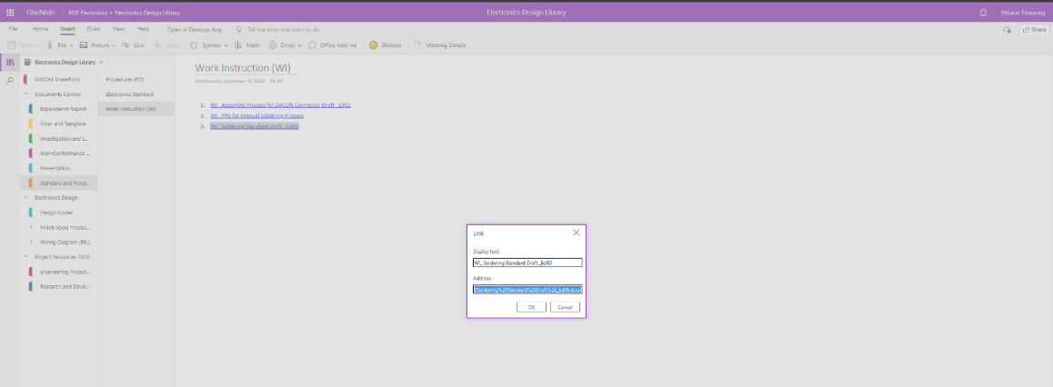

Content Registration
Control Documents

Y
N
QSMS Approved
N
Y
Submitted Documents
Y
N
Request
Approved
Documents, Design, Report, etc.
Submitted to QSMS.
Revise
Registered
- Designer has responsible to prepare all registering documents then requests to admin dept. for validate.
- Admin dept. has responsible to separate type of documents (controls/ internal) and submit controlled types to QSMS for getting approval.
- Admin dept. will register all request register documents to Electronics Design Library and confirm when process has been completed to designer for perform closed project process.
- If any documents have issue (incompatible with template, unapproved) admin dept. has authorized to reject any file that having problem.
- If designer would like to revise any documents, shall inform to admin dept to reserve document numbers (if needed, optional)

Microsoft Communities (Yammer)
Platform to share information, technical discussion for concerning project and interested components (Electronics Digests) Authorized person (HOD, project manager) only can be creating new community, but everyone can share comments or suggestion for project owner to reviews and update into project.
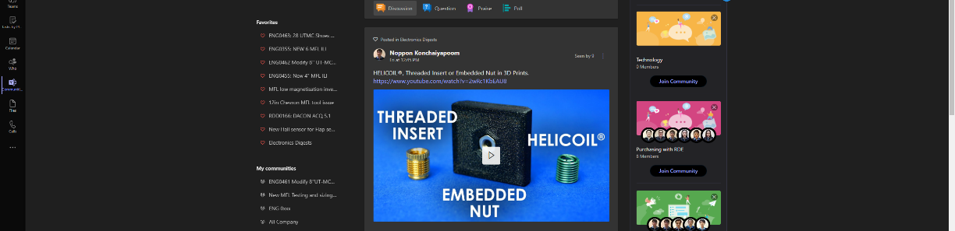

DESIGN TEMPLATE

Prefix – Suffix
      - Power Supply
Item | Code | Description | Item | Code | Description
1 | VIN | General Input Voltage | 16 | VFB | Voltage Feedback
1.1 | VI? | Voltage Input Level n | 17 | VBS | USB Volage Supply
2 | VOUT | General Output Voltage | 18 | VTL | Low Voltage Translation
2.1 | VO? | Voltage Output Level n | 19 | VTH | High Voltage Translation
3 | VCC | +5V Supply Regulated. | 20 | nVn | Represent n for Voltage Level.
3.1 | VC? | +5V Regulated Level n | 21 | GND | General Grounding
4 | VEE | -5V Negative Supply | 22 | AGND | Analog Grounding
4.1 | VE? | -5V Negative level n | 23 | DGND | Digital Grounding
5 | VCA | General Analog Filter | 24 | PGND | Power Grounding
5.1 | VXA | Voltage Analog Filtered X
6 | VDD | 3.3V Supply Regulated.
6.1 | VD? | 3.3V Regulated Level n
7 | VBT | Battery Voltage Supply
7.1 | VB? | Battery Voltage Level n
8 | VBU | Battery Backup
9 | VIO | General I/O Voltage
10 | HVP | High Positive Voltage
11 | HVN | High Negative Voltage
12 | VPP | Voltage Positive Isolation
13 | VNN | Voltage Negative Isolation
14 | VLL | Voltage Logic Control
15 | VRF | Voltage Reference

      - Color Code
Item |  | Code | Color
1 |  | BCK | Black
2 |  | BRN | Brown
3 |  | RED | Red
4 |  | ORG | Orange
5 |  | YEW | Yellow
6 |  | GRN | Green
7 |  | BLE | Blue
8 |  | PLE | Purple
9 |  | GRY | Gray
10 |  | WHT | White
      - Components Designator
Item |  | Name | Description |  | Item |  | Name |  | Description
1 |  | A? |  |  | 16 |  | P? |  | Connector/ Port
2 |  | B? | Battery |  | 17 |  | Q? |  | Transistor/ FET
3 |  | C? | Capacitor |  | 18 |  | R? |  | Resistor
4 |  | D? | Diode/ LED |  | 19 |  | S? |  | Switches
5 |  | E? | Antenna |  | 20 |  | T?
6 |  | F? | Fuse |  | 21 |  | U? |  | Integrated Circuit
7 |  | G? |  |  | 22 |  | V? |  | Voltage Regulator
8 |  | H? |  |  | 23 |  | W? |  | Jumper
9 |  | I? |  |  | 24 |  | X?
10 |  | J? | Socket/ Jack |  | 25 |  | Y? |  | Crystal Oscillator
11 |  | K? | Relay |  | 26 |  | Z?
12 |  | L? | Inductor |  | 27 |  | JP? |  | Jumper Test
13 |  | M? | Motor/ Servo |  | 28 |  | TP? |  | Test Point
14 |  | N? |  |  | 29 |  | VR? |  | Variable Resistor
15 |  | O? |  |  | 30 |  | W? |  | Jumper
      - Net Label/ Port Name: General
Item | Name |  |  | Description |  | Item |  | Name |  | Description
1 | USB |  |  | Data Communication |  | 17 |  | DNC |  | Do not Connect.
2 | PWR |  |  | Power Supply |  | 18 |  | NC |  | Not Connect
3 | PCM |  |  | Power Managements Circuit |  | 19 |  | REV.? |  | Revision Update
4 | ODO |  |  | Odometer |  | 20 |  | VER.? |  | Version Update
4.1 | ODO? |  |  | Odometer Channels n |  | 21 |  | SMD |  | Surface Mount Deceive
5 | PT? |  |  | Pressure/ Temperature n |  | 22 |  | THP |  | Through Hole Derive/ Pin
5.1 | P? |  |  | Pressure Signal n |  | 23 |  | PAD |  | Soldering Point
5.2 | T? |  |  | Temperature Signal n |  | 24 |  | LED |  | Light Indicator
6 | USB |  |  |  |  | 25 |  | SD_CMD |  | Command
6.1 | USB? _ID |  |  |  |  | 26 |  | SD_CLK |  | Clock
6.2 | USB? _P |  |  | Differential Positive |  | 27 |  | SD_DAT? |  | Data Communication n (0...3)
6.3 | USB? _N |  |  | Differential Negative
6.4 | USB? _L? |  |  | USB LED
7 | I2C
7.1 | I2C? _P |  |  | Synchronize Data (SDA)
7.2 | I2C? _N |  |  | Synchronize Clock (SCL)
8 | UART
8.1 | TX? _P |  |  | Differential Positive
8.2 | RX? _N |  |  | Differential Negative
9 | EN |  |  | Enable (Active High)
10 | ENB |  |  | Enable (Active Low)
11 | RUN |  |  | RUN (Enable Pin)
12 | SENS |  |  | Sensor Output
13 | SCLK |  |  | Synchronize Clock
14 | SHDN |  |  | Shutdown Function
15 | WKUP |  |  | Weak-Up Signal Status
16 | DNI |  |  | Do not Install.
      - Net Label/ Port Name: CAL
Item | Name |  |  | Description |  | Item |  | Name |  | Description
1 | CAL X |  |  | Control Connector
2 | ADC? |  |  | Analog to Digital Converter n
3 | ARM? |  |  | Arm Sensor Number n
4 | CAL_CSB |  |  | Chip Select (Active Low)
5 | CAL_CLK |  |  | Reference Clock
6 | CAL_DIN |  |  | Data Input
7 | CAL_DO? |  |  | Data Output n
8 | CAL_L? |  |  | Caliper LED
9 | CAL X |  |  | Control Connector
10 | ADC? |  |  | Analog to Digital Converter n
      - Net Label/ Port Name: IMU
Item | Name |  |  | Description |  | Item |  | Name |  | Description
1 | IMU_CSB? |  |  | Chip Select Pin n
2 | IMU_SCLK |  |  | Synchronize Clock
3 | IMU_MISO |  |  | Master-In Slave-Out
4 | IMU_MOSI |  |  | Master-Out Slave-In
5 | IMU_DRDY |  |  | Ready Signal Status
6 | IMU_NRST |  |  | Negative Reset Status
7 | IMU_L? |  |  | IMU LED

      - Net Label/ Port Name: UTM
Item | Name | Description | Item | Name | Description
1 | TRS | Transducer Signal
2 | ACQ | Data Acquisitions Unit
3 | APG | Analog Pulse Generator
4 | DPG | Digital Pulse Generator
5 | UTM_LEB | Latched/ Enable
6 | UTM_CLK | Reference Clock
7 | UTM_DIN | General Data Control
8 | UTM_DI? | Data Control Channels n
9 | UTM_L? | UTM LED
10 | UTM_TR? | Transducer n
11 | UTM_AE? | AFE Port n
12 | UTM_MX? | Multiplexer Control n
      - Net Label/ Port Name: MFL
Item | Name | Description | Item | Name | Description
1 | HUB | Communication Sharing
2 | BUS | Communication Line
3 | FLP | MFL Sensing
3.1 | FLP-? X | Output Signal x-axis
3.2 | FLP-? Y | Output Signal y-axis
3.3 | FLP-? Z | Output Signal z-axis
4 | MFL_DO? | Data Out Channels n
5 | MFL_A? | Data Address n
6 | MFL_CSB? | Chip Select Pin n
7 | MFL_SCLK | Synchronize Clock
8 | MFL_MISO | Master-In Slave-Out
9 | MFL_MOSI | Master-Out Slave-In

Schematic Capture
Design template has available for sheet in landscape orientation with paper size A4 to A0

Symbols and Marking
Antenna | Battery | Capacitor | Capacitor Polarity | Diode Schottky | Diode Zener
Diode Rectify | Fuse | Inductor | Inductor Core | Jumper | LED
MOSFET-N | MOSFET-P | Motor | Motor Servo | Motor Steps | Integrator Circuit
BJT-NPN | BJT-PNP | Photo Sensor | Resistor | Variable Resistor | Switches Button
Switch SPDT | Switch SPST | Crystal Oscillator | AC Plug | DC Jack | USB Connector
Coaxial | MMCX | Single Row Connector | Dual Row Connector | Dual Row Connector | SD-Card Socket
Analog GND | Digital GND | Earth | Voltage Sources | Differential Pair | No ERC

Port and Netlabel
Connection Ports | Comment/ Note
Blanket | Blanket with Rule Parameters

Net Colors Highlight
Color |  | Functionals
Yellow |  | Main voltage supply/ sources
Red |  | Circuit voltage supply
Green |  | Analog signal
Light Green |  | Digital signal (logic, no protocol)
Blue |  | Low speed communication
Light Blue |  | High speed communication
Fuchsia |  | High power signal

Parameters and Title Block
- Design number: Will be relative with the Finish Good Number (EEP)
- Size: Sheet size (A0 … A4)
- Revision: Update revision (Not more than 3 updates / each project)
- Sheet * of *: Sheet numbering per project.
- Engineer: Project designer/ Project creator.
- Reviewed: Reviews state from Partner Engineer or Senior Engineer
- Approved: Signature to approved in final state.

Schematic Components Placed Guideline
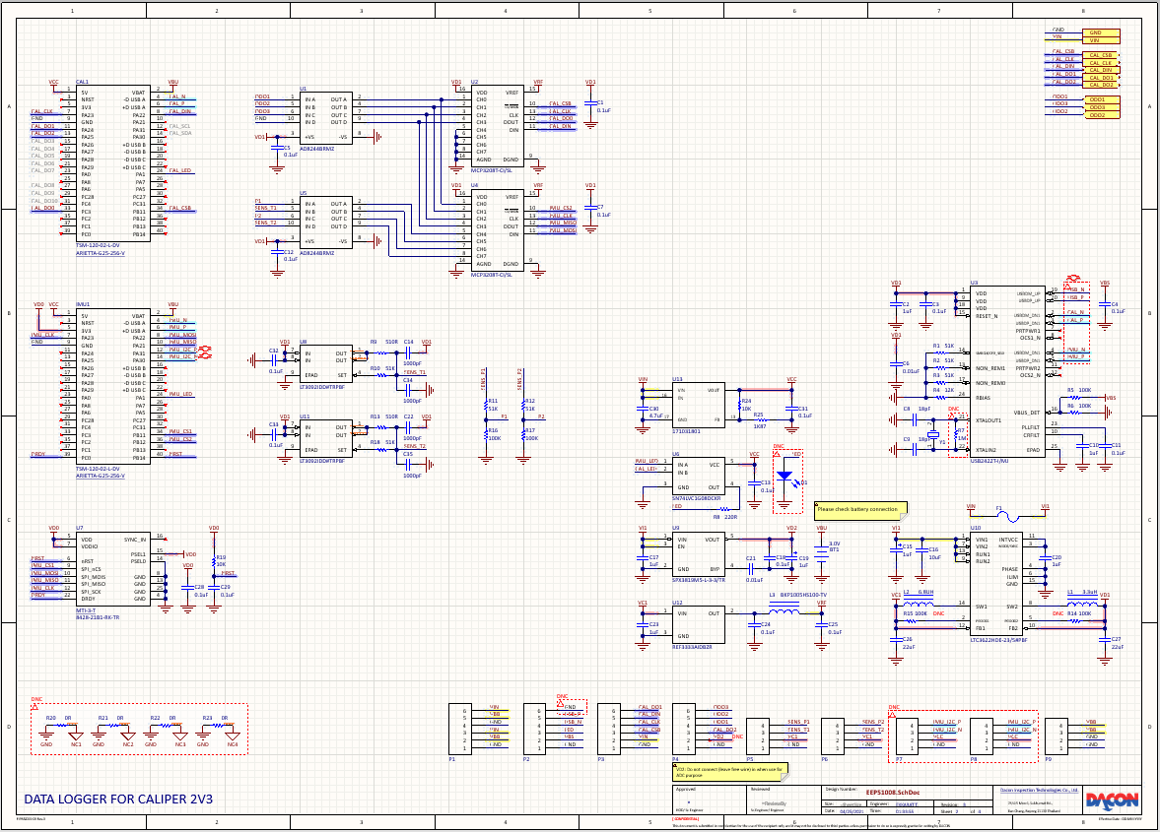
B
D
C
F
E
A
  - Control Unit Please processing unit or main parts for this sheet.
  - Multi-sheet Port Place port for connecting within multiple sheet design.
  - Auxiliary Parts Place auxiliary item in circuit (indicator, communication, etc.)
  - Power Supply Place voltage regulator or convertor circuit.
  - Protection Place protection components (fuses, EMI shielding, etc.)
  - Connector Place on-board connector.

PCB Layout

Layer Stack Manager
Layers Types | Layer Name | Prefix | Pullback (mil)
Signal | Top | TOP
Signal | Bottom | STB
Signal | Signal? | S?
Internal Plane | Ground Plane | GND | GND < PRW
Internal Plane | Power Plane | PWR | PWR > GND

Circuit Board Material
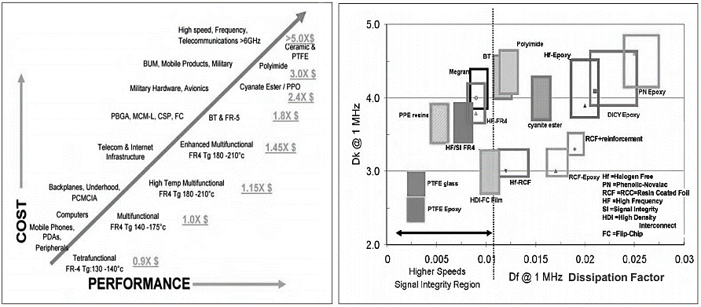

Hole and Via Properties
Types | Largest Ø (mm) | Angular Ring (um) | Aspect Ratio
Blind Via | ≤ 0.4 | ≥ 100 | 1:1
Buried Via | ≤ 0.4 | ≥ 100 | 1:12
Thru-hole Via [NPTH] | 6.0 |  | 1:10
Thru-hole Via [PTH] | 6.0 |  | 1:8
$$Aspected Ratio= \frac{∅ Drill Hole Diameter}{Board Thickness}$$

Surface Finished
Comparison | HASL | OSP | IAg | ENIG | Hard-Gold | ENIG/SMOBC
Surface Co-planarity | Poor | Best | Good | Best | Best | Good
Solder Contrast | Poor | Best | Good | Best | Good | Best
Electric Contact Use | Fair | Poor | Good | Good | Good | Good
High Frequency Loss | Fair | Best | Best | Poor | Poor | Good
Environmental Hazard | Pb | Water Based | Ag | Ni | Ni | Ni
Cost from Standard | 1.0x | 0.3x | 1.0x | 2.0x | 2.0x | 1.3x

Draftsman Drawing

Draftsman Contents
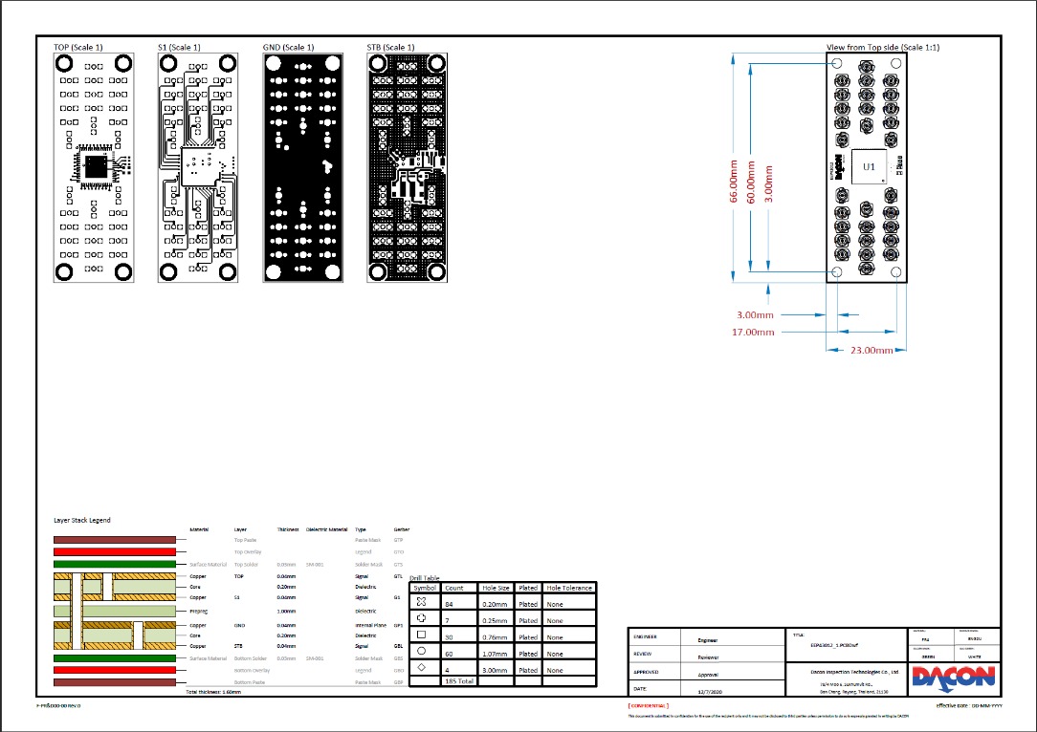
C
D
A
B
- Layers Show all layers to verify of design compatible.
- Layers Stack Show all stack-up properties and total board thickness (mm)
- Drill and Hole Show all drill types and size counts.
- Dimension Show board shape/ size, position, and components orientation.

Parameters and Title Block
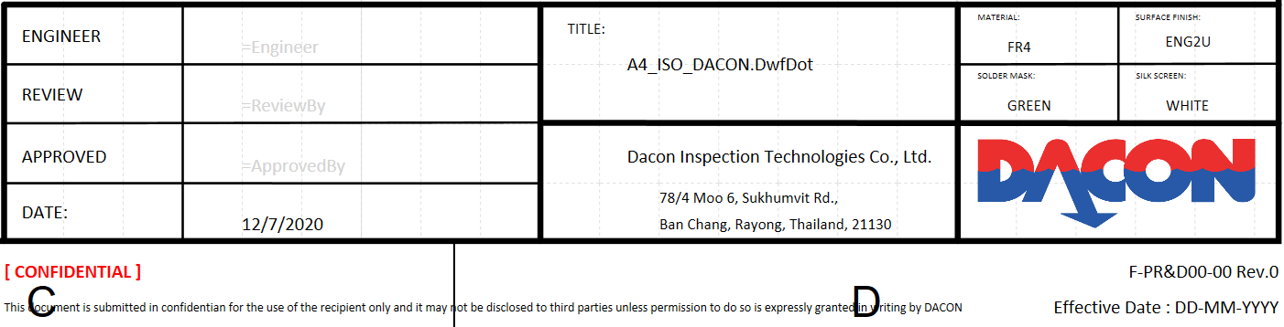
      - Material and Surface Finish Identify board material properties.
      - Solder Mask and Silk Screen Identify surface colors.
      - Engineer Project designer/ Project creator.
      - Reviewed Reviews state from Senior Engineer
      - Approved Approves by Relevant Engineer

Components Library

Component Parameters
Design components shall be required parameters as below table to be compatible for BOM and BOC format but some of them are optional only.
Parameters | Design | Part Choice | User | Required | Optional
- Description | P |  |  | P
- Designator | P |  |  | P
- Quantity | P |  |  | P
- Manufacturer 1 URL |  |  | P |  | P
- Manufacturer 1 |  | P | W | P
- Manufacturer Part Number 1 |  | P | W | P
- Supplier 1 |  | P | W |  | P
- Supplier Part Number 1 |  | P | W |  | P
- Value |  |  | P |  | P
- Matching 2 Description |  |  | P | P
- Matching 2 Quantity |  |  | P |  | P
- Matching 2 URL |  |  | P |  | P
- Manufacturer 2 |  | P | W |  | P
- Manufacturer Part Number 2 |  | P | W | P
- Supplier 2 |  | P | W |  | P
- Supplier Part Number 2 |  | P | W |  | P
- System: Connector |  |  | P |  | P

Part Choice (Altium Designer)
Powerful feature to source electronic item in online server to be getting component information, stock quantity, etc. This feature has generated information background that cannot be modified.
- Newly create item is not commercial type, designer shall create parameters of parts choice by manually.
- If main components have no part choice available, but matched item has required. Thus, designer shall create blank parameters.

Bill of Materials (BOM)
Design software has supports to generate bill of material which be referencing information from component library. If they are having some duplicate or missing content, then error message will be displaying. BOM will contain items which mounting on PCB only.
- Request quantity: Auto calculated from standard procedure controls.
- Components Type: Choose new for item which never register to SAP system.

Components Request (BOC)
Some of them can be generated from design software, in function of matching product. General items could be included into this list by insert next row from last item of auto-generation created.

PIN FUNCTIONAL ASSIGNED
    - Charger
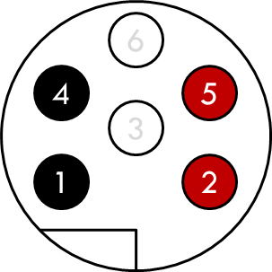 | PIN | FUNCTIONAL
 | 1 | GND
 | 2 | VBT
 | 3 | VIN
 | 4 | GND
 | 5 | VBT
Marking: PWR | 6 | VIN
    - Start Key
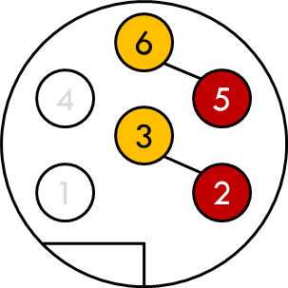 | PIN | FUNCTIONAL
 | 1 | GND
 | 2 | VBT
 | 3 | VIN
 | 4 | GND
 | 5 | VBT
Marking: PWR | 6 | VIN
    - Odometer (common)
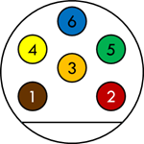 | PIN | FUNCTIONAL
 | 1 | GND
 | 2 | VDD
 | 3 | ODO1
 | 4 | ODO2
 | 5 | ODO3
Marking: ODO | 6 | VIN
    - Odometer (individual)
 | PIN | FUNCTIONAL
 | 1 | GND
 | 2 | VDD
 | 3 | ODO?
 | 4 | -
 | 5 | -
Marking: ODO? | 6 | -

    - General Sensor
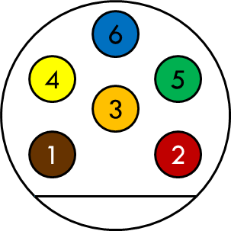 | PIN | FUNCTIONAL
 | 1 | GND
 | 2 | VDD
 | 3 | SENS1
 | 4 | SENS2
 | 5 | SENS3
Marking: S? _{n+4} [XX] | 6 | SENS4
    - Communication (single)
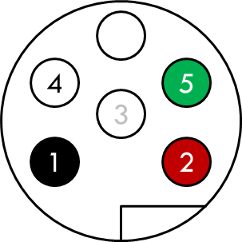 | PIN | FUNCTIONAL
 | 1 | GND
 | 2 | VBS
 | 3 | LED
 | 4 | USB_D-
 | 5 | USB_D+
Marking: COM? | 6 | -
    - Indicator Plug (type A)
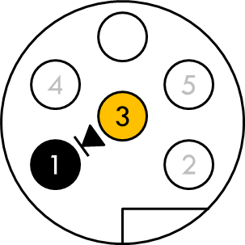 | PIN | FUNCTIONAL
 | 1 | GND
 | 2 | VBS
 | 3 | LED
 | 4 | USB_D-
 | 5 | USB_D+
Marking: COM? | 6 | -
    - Communication (dual)
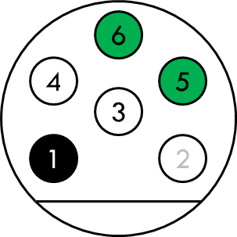 | PIN | FUNCTIONAL
 | 1 | GND
 | 2 | LED
 | 3 | IMU_D-
 | 4 | USB_D-
 | 5 | USB_D+
Marking: COM? | 6 | IMU_D+
    - Indicator Plug (type B)
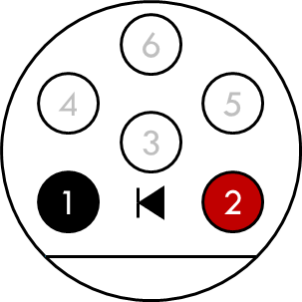 | PIN | FUNCTIONAL
 | 1 | GND
 | 2 | LED
 | 3 | IMU_D-
 | 4 | USB_D-
 | 5 | USB_D+
Marking: COM? | 6 | IMU_D+
    - Caliper Control (CAL A)
 | PIN | FUNCTIONAL
 | 1 | GND
 | 2 | VIN
 | 3 | CAL_CSB
 | 4 | CAL_CLK
 | 5 | CAL_DIN
Marking: CAL A | 6 | CAL_DO1
    - Caliper Control (CAL B)
 | PIN | FUNCTIONAL
 | 1 | GND
 | 2 | CAL_DO2
 | 3 | CAL_DO3
 | 4 | CAL_DO4
 | 5 | CAL_DO5
Marking: CAL B | 6 | CAL_DO6
    - Caliper Control (CAL C)
 | PIN | FUNCTIONAL
 | 1 | GND
 | 2 | VDD
 | 3 | CAL_DO2
 | 4 | ODO1
 | 5 | ODO2
Marking: CAL C | 6 | ODO3

    - Caliper Control (CAL D)
 | PIN | FUNCTIONAL
 | 1 | GND
 | 2 | VIN, VCC
 | 3 | VDD
 | 4 | CAL_CLK
 | 5 | CAL_DIN
Marking: CAL D | 6 | CAL_CSB
    - Caliper Control (CAL E)
 | PIN | FUNCTIONAL
 | 1 | CAL_DO0
 | 2 | CAL_DO1
 | 3 | CAL_DO2
 | 4 | CAL_DO3
 | 5 | CAL_DO4
Marking: CAL E | 6 | CAL_DO5
    - UTM Multiplexer (MUX A)
 | PIN | FUNCTIONAL
 | 1 | GND
 | 2 | VCC
 | 3 | HVN
 | 4 | UTM_LEB
 | 5 | UTM_CLK
Marking: MUX A | 6 | UTM_DI1
    - UTM Multiplexer (MUX B)
 | PIN | FUNCTIONAL
 | 1 | GND
 | 2 | UTM_DI2
 | 3 | UTM_DI3
 | 4 | UTM_DI4
 | 5 | UTM_DI5
Marking: MUX B | 6 | UTM_DI6

    - UTM Multiplexer (MUX C)
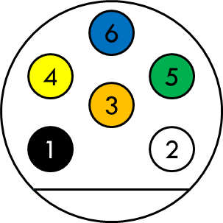 | PIN | FUNCTIONAL
 | 1 | GND (Shield)
 | 2 | TR _{n}
 | 3 | VIN
 | 4 | UTM_LEB
 | 5 | UTM_CLK
Marking: MUX C | 6 | UTM_DIN
    - Transducer (common-5)
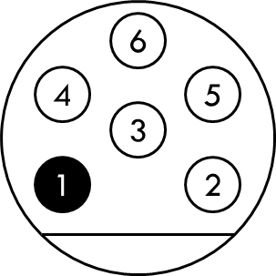 | PIN | FUNCTIONAL
 | 1 | GND (Shield)
 | 2 | TR1
 | 3 | TR2
 | 4 | TR3
 | 5 | TR4
Marking: TR? _{n+5} [XXX] | 6 | TR5
    - PT Sensor
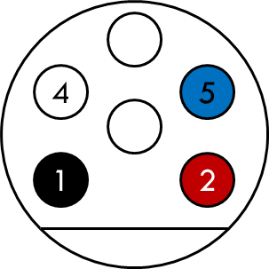 | PIN | FUNCTIONAL
 | 1 | GND
 | 2 | VCC
 | 3 | -
 | 4 | T?
 | 5 | P?
Marking: PT? | 6 | -

    - MFL Data Flap Output (FLP A)
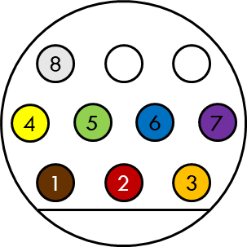 | PIN | FUNCTIONAL
 | 1 | FLP1
 | 2 | FLP2
 | 3 | FLP3
 | 4 | FLP4
 | 5 | FLP5
 | 6 | FLP6
 | 7 | FLP7
 | 8 | FLP8
 | 9 | -
Marking: DAT? | 0 | -
    - MFL BUS Address (BUS A)
 | PIN | FUNCTIONAL
 | 1 | DGND
 | 2 | VCC
 | 3 | -
 | 4 | MFL_A1
 | 5 | MFL_A2
 | 6 | MFL_A3
 | 7 | MFL_A4
 | 8 | MFL_A5
 | 9 | -
Marking: BUS? | 0 | -

RECORDS / บันทึก
Updating history before register in QSMS
ENGINEER | DATE | DESCRIPTION
EKKARAT T. | 16-11-2020 | Published first version.
EKKARAT T. | 26-11-2020 | Update MFL standard and general functional assign for 10 pins connector.
EKKARAT T. | 30-11-2020 | Add content of files managements and documents form.
EKKARAT T. | 08-12-2020 | Add content of electronics project and bill of material.
EKKARAT T. | 10-12-2020 | Add content of OneNote and update purchasing procedures.
EKKARAT T. | 04-01-2021 | Add content of Task Update (MS Teams)
EKKARAT T. | 17-03-2021 | Add individual odometer pin assignments
EKKARAT T. | 25-04-2021 | Add content of Microsoft Communities (Yammer)
EKKARAT T. | 26-04-2021 | Electronics Online Approved and Schematic Components Placed Guideline
EKKARAT T. | 27-04-2021 | Engineering Electronics Code (EEP CODEX)
EKKARAT T. | 28-04-2021 | Components Description – requesting procedures.

DETAILS OF CHANGED / รายละเอียดการเปลี่ยนแปลง
Rev. No. | Rev. Date | Details of Changed
00 | 30 Apr 21 | Initial release

Physical design of connector mating has difference from other types.
Plugged to same port with charger connector.
Physical design of connector mating has difference from other types.
Standard USB cable with shield between jacket material.
Plugged to same port with communication connector.
Physical design of connector mating has difference from other types.
Please avoid using dual connection, because will affected by crosstalk signal issue.
Plugged to same port with communication connector.
Support single multiplexer chip control and daisy-chain topology ONLY!
Connected to OEM cable from PT sensor (color has been specific)

